What to Bring on your Wild Weekend

- Bin bag – remember we are a ‘leave no trace’ campsite so what goes in much come out!
- Clothes & spares – long trousers (nettles & brambles), long sleeves, layers that you can easily add or remove as needed, wind & waterproof jacket
- Food and drinks – recipe ideas for cooking on an open fire included below
- Roll mat
- Sleeping bag (& inflatable pillow)
- Small backpack/ day bag (For your personal water bottle/phone/sun cream /hat- things you want on the walk as cannot unpack ponies until camp).
- Strong boots – long or ankle length – will make your walk more comfy, less hazardous and keep your feet in one piece if a pony steps on you!
- Light footwear (you’ll want to take those boots off in the evening! Mark likes to bring flip flops, I bring soled slippers!)
- Basic First Aid kit (including insect repellent)
- Torch
- Lighting
- Towel & wash kit.
- A smile & a sense of adventure!

What is Provided on your Wild Weekend

- Tents
- Cooking utilities – pots, pans, a Dutch oven, kettle, utensils
- Dining essentials – plates, bowls, cups, cutlery
- Kitchen essentials – salt, oil, dish cloths, tea towels, washing up liquid
- Firewood.

Onsite Facilities

This is wild camping, so there isn’t a reception or evening disco, but we do have an outdoor ‘long drop’ loo, a basic outdoor shower (cold water only!), a small, central covered area with log seating in case of rain or the desire to socialise with others.

What you Need to know About the Loos

We have built our own composting loo with a long drop pit below. Please use these loos for poos, but whenever possible go for wild wees. To help with the composting process please put sawdust (there will be a tub of it next to the ‘thunder box’) on top of your waste in the drop below the loo. It’s ok to put small amounts of loo roll down there – any sanitary products need carrying out.

Food, yummy, yummy food!
After watching my kids grow, walking and time with the ponies, food is probably my next big thing. I will carry steaks & all the accessories into the remotest part of Dartmoor rather than a nice easy lightweight boil-in-the-bag! So, when people ask me what food they should bring, I am torn. I know my family are as tolerant about my mistakes as they are enthusiastic about my successes, so when the campfire bread doesn’t rise, or the omelette becomes scrambled egg with things in, it’s all a big giggle. Here are some of the things that have worked for us, I can’t promise they’ll work every time or that it’ll even be your thing. I can say camping shops do a varied and very fail-safe option in the dehydrated/ boil in the bag range well worth checking out!
A few tips - I freeze as much as I can beforehand: milk, juice, sausages – if it can be frozen, freeze it! Pack this into your insulated bag, keep the bag closed & shaded as much as possible and it’ll be good for 24 hours at least, weather depending.
Downsize – pack only as many tea bags & as much coffee as you’ll need, and maybe one spare. If you want a drink in the evening – a hip flask works better than a full-size glass bottle and most mixers can come in lightweight plastic bottles. In this way we discovered whiskey & brandy in tea is really quite do-able, but you might want to test this beforehand, just to be sure! At the same time, 15kg (the weight the ponies can carry for you) is quite a lot – this picture (below) came to about 11kg which does leave you plenty of room to bring whatever you like.
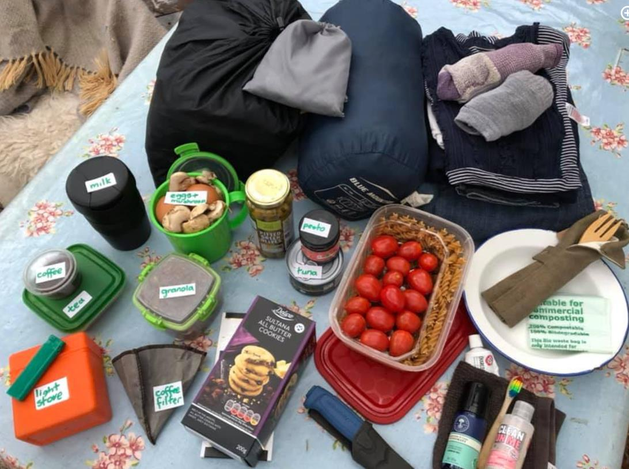

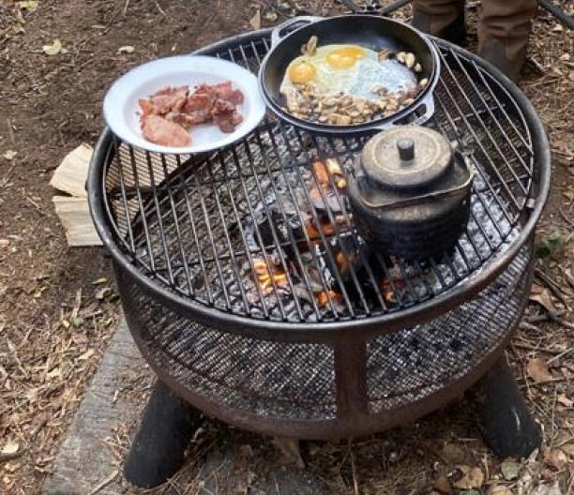
This is your hob & oven for the trip – we provide wood and fire starting kits.

Breakfast ideas:
Granola & fruit, porridge & fruit, omelette (I like to chop mushrooms, peppers, spring onions into a container, then pack the eggs into it – I haven’t had a broken egg yet!), sausage/bacon etc. Wraps work better than rolls.
‘Chinese pancakes’ – inspired from the Taiwanese ‘dan bing’ this is basically an egg beaten with a sprinkle of chopped up spring onion, you can add grated cheese if you like, then pour into a hot oiled frying pan and when the bottom is set (almost immediately) put a wrap on the top and gently squash it down. When the egg mixture is cooked take it out, roll it up and enjoy. One of the few times I recommend ketchup!
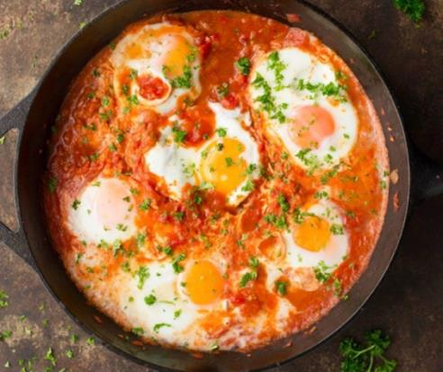
‘Shakshuka’ It’s one of our favourites and is very flexible – you can have it for dinner with rice, for breakfast by itself or add bread. You can add beans, bacon, salami, whatever you like, we even use a version this as tomato soup, but this is the basic recipe:
- 1 tsp. ras al haunt (a mix of spices)
- 2 chopped onions
1 chopped red pepper
Oil
- Chopped tinned tomatoes (plain)
- Passata
1 or 2 eggs per person
Add the chopped onions to oil, fry, add the ras al haunt and fry for another minute or two, add the pepper, fry another couple of minutes, then add the tomatoes & passata. Then make little gaps in the onion & pepper mix with a spoon, so only the liquid is in a table spoon sized area & break an egg into there. Repeat until all your eggs are in and cover the pan. Remove from the heat when the eggs are cooked to your liking. Add coriander leaves if you’d like.
Meals:
Pasta meals – including gnocchi & tortellini - a jar of pesto or stir through sauce can be spiced up with cherry tomatoes, diced cucumber, tuna, sweetcorn, ham, olives, salami etc.
Cous-cous – as per pasta but prep cous-cous in your main pan, chop the chosen ingredients together, stir through your sauce then mix with cous-cous. I found the best way to do this is boil a kettle, pour the boiling water over the cous-cous, put a lid over it and LEAVE it alone! After five or ten minutes, fluff it with a fork and mix your meal into it.
Any sausages & beans – fry your sausages, add a tin of beans to the pan to heat up and a bread roll, loads of carby energy for the day!
Steak, mushrooms, onion & ciabatta rolls (in this case a wrap just doesn’t cut it!). Buy the vacuum-packed steaks & freeze beforehand. You can pre chop the mushrooms & onion and put them in a container. I don’t like recommending plastic, but it does the job well.
Risotto – any flavour, always good!
Jacket potatoes prewrapped in foil – you can even pre-cook them at home and reheat on the camp fire.
Carrot salad – sounds like a waste of time, but it really adds something to most meals, especially wraps, it keeps and transports well. Grate a shed load of carrots, mix with olive oil, salt, balsamic vinegar, black pepper & raisins. Done. It creates its own juice which plumps up the raisins so definitely worth preparing the day before and bizarrely, children love it!
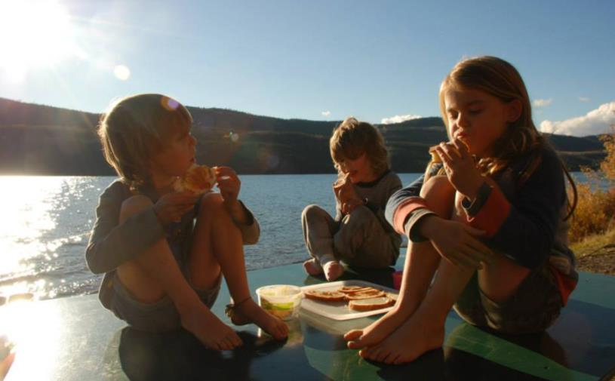
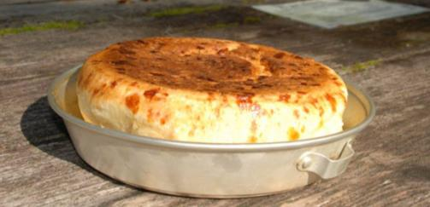
If you’re feeling really adventurous, it is possible to make bread & pitta bread on the campfire, same recipes as you’d normally use, but bring the dry ingredients ready mixed and add in the water on camp. Our camps all come with a Dutch oven for use on the fire which works well for risen bread and pita alike.
Lastly, snacks. Bring biscuits, treats, whatever you like. This is an adventure, not an endurance test!

And sometimes, they still just want peanut butter & jam on toast!

